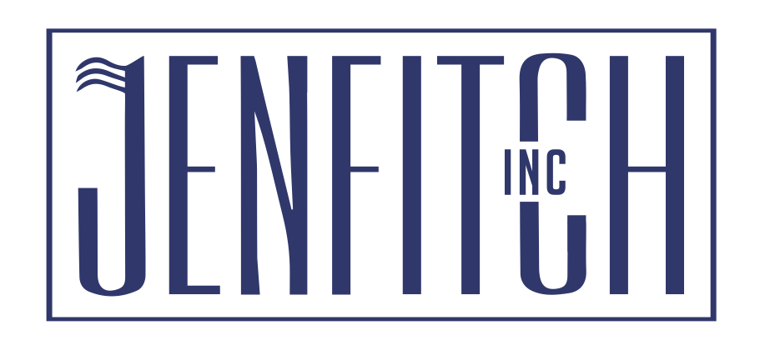
Jenfitch conducted a study at a facility in Northern California. On March 2, 2022, we collected data on the influent of their water treatment system. The raw water turbidity was 2.13 NTU and the UvA₂₅₄ was 0.075. The plant was using their original product at 60 mg/l as a primary coagulant. The goal of this study was to optimize treatment and lower NOM (natural organic matter) as measured using UvA₂₅₄ and compare their original coagulant to JC 1675.

Using the standard jar testing method and filterability protocol (see attached “Jar Testing Procedure and Filterability Test Procedure-modified”), we found that feeding JC 1675 at 60 mg/l generated the most economical treatment to generate the lowest settled water turbidity and best NOM removal as measured by UvA₂₅₄. In the graphs attached, JC 1675 significantly outperformed their current technology, which they have been using for 20 years. JC 1675 improved filter performance, organic removal (as measured by NOM) and used a lower dosage to achieves these results.

We recommend to this this Northern California plant to conduct a 60-day plant trial with JC 1675 to confirm our results. As the plant incorporated our chemical in their plant’s water, they saw significant improvements in their water quality markers like lowering UVA, NTU (Turbidity), and improving filter efficiency. JC 1675 is a high charged/low molecular weight organic/inorganic coagulant that is very effective at removing organic contaminants. JC 1675 is a new and improved coagulant on the market.

If you have any questions, please feel free to contact us anytime at (925)289-3559 or email us at sales@jenfitch.com.

